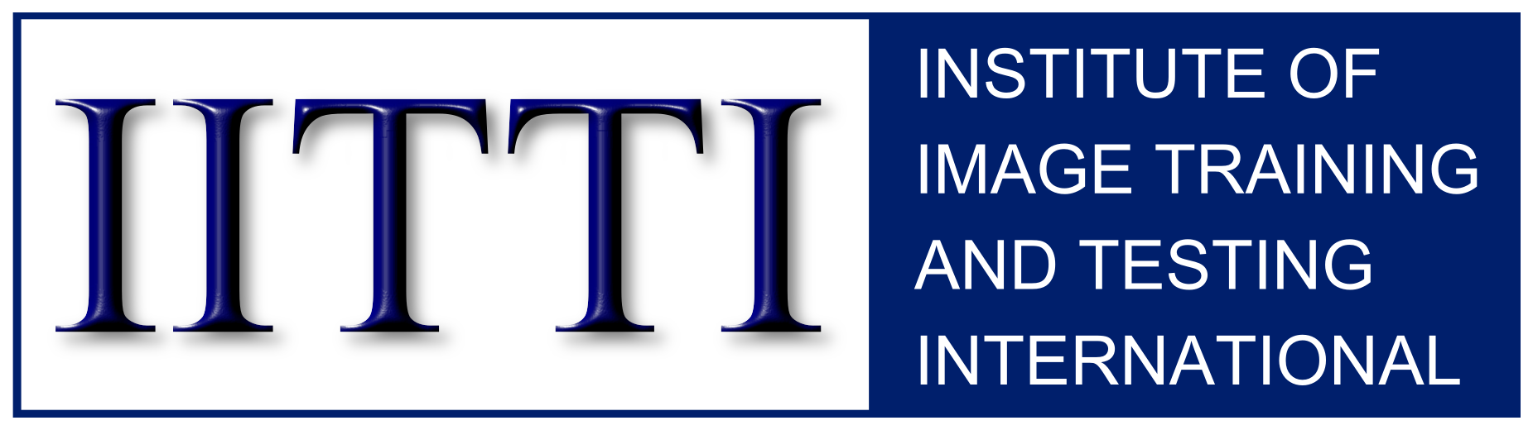
TM

HR Department Manual
March 25, 2016

Jun15,2015 (minor formatting)
Mar25,2016 (benefits for companies)
(All recent changes are highlighted in yellow.)

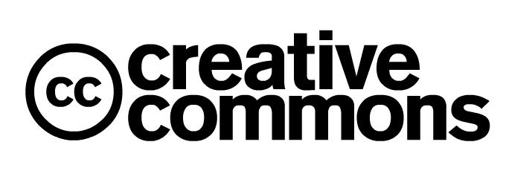

2011-2016 Institute of Image Training and Testing International (IITTI).
You can freely distribute this document.

Table of Contents
Executive Summary 3
Chapter 1 The Business Case 4
Needs we fulfill 4
Challenges facing corporate HR 4
The IITTI solution 5
Chapter 2 The IITTI Exam 7
What is the Exam like? 7
Anything fun? 8
What does the Exam actually look like? 8
Chapter 3 Content of the test 10
Chapter 4 How can we adopt IITTI? 11
What is the first step? 11
How can we advertise IITTI in our recruitment? 11
How can we verify that a job-seeker really had passed an IITTI test? 11

Executive Summary

Your company's brand is not only felt by your customers through your products, but the quality of interactions with your employees. So how much would you be willing to invest to improve the soft skills of your people? However, the current lack of a standardized measuring tool for soft skills makes raising such skills difficult. But think, for example, of what ISO has done in raising the standards for the many industrial processes in the last couple of decades. Now think IITTI as exactly like ISO, but for soft skills, particularly with a focus on corporate appearance, behaviour and communication. By demanding new hires to have certification from IITTI, your company can pre-screen job candidates who already have the awareness and a certain level of competency in these skills. Not only will you save money from duplicating such training, but you will also enhance your company branding in the eyes of customers, as well as employer branding in the eyes of job-seekers.

Chapter 1 The Business Case

Needs we fulfill
Currently there are no image standards such as dress codes or policies for professional conduct in corporations. Our research shows that corporations have identified such standards as missing and seek a means of upgrading the skills of their internal employees and interviewees.

Challenges facing corporate HR
1. A lack of a standardized measurement system for image and soft skills.
We frequently hear that soft skill trainings are treated as a discretionary activity, a "second-class citizen" in the corporate training world.
But in-depth discussions with many human resource (HR) professionals would reveal that it is not that they don't understand the importance of appropriate appearance, behavior, or communication, but the lack of a standardized measurement system that they can count on during the hiring and evaluation process.
2. Justifying that image and etiquette training improves the bottom line.

The problem right now is that graduates of corporate image & etiquette training programs have a difficult time substantiating to employers the quality of training they have received. Anyone can create a website calling themselves an image or etiquette consultant. And unless the employer already has some prior knowledge of the particular corporate trainer beforehand, the certificate employees receive from the training program probably would mean little to the employer.

Worse yet, unaware that corporate image and etiquette consulting is a profession, with professional standards, employers may find themselves hiring untrained consultants with only a retail background or unqualified consultants who tack professional appearance and etiquette onto their training curriculum. As a result, HR's find it difficult to justify the value of the training to their bosses, when they can't demonstrate the return on investment (ROI).

3. Unfamiliar curriculum to HR.
Few HR's of the world are familiar with the quality of what any single school can provide. Some corporate image & etiquette trainers provide top-notch services and a solid curriculum, while others provide poor-quality curriculum and few benefits.
4. No standardization in image curricula or image consulting trainings.
The corporate HR can't judge image and etiquette training easily because different certificates from different schools may mean different things. It would be like asking HR's to compare somebody with a kindergarten diploma vs. another person with a high school diploma. A standardized certification system would eliminate this issue of comparing apples and oranges.
5. It is a lose-lose-lose situation.
A. The image and etiquette consultant can't fully gain the recognition he/she deserves in the marketplace; he/she gets less business.
B. If the training received is inadequate, employees do not receive the credit they deserve for their dedication to learning the training curriculum. With inadequate skills they might not get the job or get the promotion.
C. The organization loses because they suffer from employees who have sub-standard behaviour, communication skills and appearance. And the brand suffers.

The IITTI solution
1. IITTI's role.
IITTI has developed standardized tests on international business standards of appearance, behaviour, business protocol and communications. IITTI recommends that these international business image and etiquette standards be adopted in the business arena worldwide.
2. Eliminating any conflict of interests.
A serious issue with home-spun certificates from various image and etiquette training schools is that it casts doubt on the credibility of such training. It is not so much about an image consultant not doing a good job, but providing the training and also the assessment present a case of conflict of interest. Having an unbiased, independent, international body such as IITTI doing the assessment would eliminate this conflict of interest.
3. The market can all "speak the same language".
When every party is "on the same page", it streamlines the inefficiencies. Image consultants would no longer need to educate the market about a particular certification system (which takes time and resources from all parties), graduates would know exactly what they get at the end of the training (and tell prospective employers), and HR's could embrace the standard and measure soft skills more readily.

4. Justifying that image and etiquette training improves the bottom line.

Instead of dealing with something that cannot be measured easily and in a standardized way for ROI calculations, IITTI changes all this. Think, for instance, how does your company justify the adoption of the ISO standards in terms of ROI? Now think of IITTI as the ISO standard for image and etiquette.

5. Good for branding.

In terms of your recruitment effort, by specifying that you will give preference to IITTI Certificate holders, there are several advantages.

(1) Imagine when your HR advertises:

"We prefers job candidates with IITTI certification"

You are advertising to the world that your company cares about the importance of good image and etiquette practices – good for employer branding.

(2) It automatically screens job candidates with the initiatives to understand the importance of soft skills.

(3) You save money not needing to train employees on the fundamentals.

(4) Imagine if your company can tell your customers something like:

"25% of our staff are IITTI-certified"

Better quality employees means better interactions with customers – good for company branding.

Chapter 2 The IITTI Exam

What is the Exam like?
There are three (3) levels of certification:

(1) Level 1, Basic
(2) Level 2, Standard
(3) Level 3, Advanced

We find it useful to describe each level with a single word or phrase; this allows everybody to describe very concisely what each level is about:

(1) Level 1, Basic - "keeping up"
(2) Level 2, Standard - "fluency"
(3) Level 3, Advanced – "refined"

Why three levels? There is a market reason behind them. Think of Level 1 as the "survival", or "keeping up" level. It is designed to evaluate your employee's interpersonal skills in the three areas of business etiquette: business dress, business behaviour, and dining etiquette for business interaction. Passing this exam ensures that the employee can identify appropriate and inappropriate behaviour - and have the necessary knowledge to not embarrass the company. It is a vehicle that allows you to raise the general awareness of the importance of appropriate appearance, behaviour and business communication in the workplace. It is about improving the company culture, and thus its brand.

With this in mind, the IITTI Level 1 is designed to be a compact unit. It is not a full-fledged business etiquette exam. It tests the knowledge that is minimally acceptable for the uninitiated. Anybody who works with people in the international market would be a good candidate. It is a "catch all".

Level 1 exam is designed to verify the foundational skills. These skills may be further enhanced through company-specific policy to deal with your particular needs, or through enhanced training criteria in preparation for the IITTI Level 2 exam.

Level 2 is designed for a more particular group of audience. It is meant to be a full-fledged, wide-spectrum delivery for people who really want to have an advantage in their own branding. While Level 1 is there to help prevent people from making big mistakes that would embarrass themselves and the companies they represent, Level 2 is there to help enhance people in standing out in the crowd.

We ask Level 1 candidates to demonstrate knowledge, with only a written test. But Level 2 is where the "rubber meets the road"; not only would candidates need to sit for a written exam, but it is also where they would need to physically demonstrate their skills in front of an examiner. There is no faking it!

At a Level 2 practicum exam, candidates would need to demonstrate fluency in the execution of their skills. For example, if the examiner asks a candidate to demonstrate the American style of dining, we would expect the candidate not to hesitate in transferring the fork from the left hand to the right for eating.

At Level 2, expected skills should be second-nature. Successful candidates are those who have formed good habits by putting into practice the learned skills. You may call it a form of "muscle memory", just like top athletes can perform their skills "in their sleeps"!

Level 3 is a high-level critique. It calls for successful candidates to have not only mastered the essence of business image & etiquette, but also take it to the next level of refinements by reinforcing the learning outcomes through real world experience. The exam is a critiqued practicum conducted at our test centre in Vancouver, Canada. The focus is to put into practice the learned skills in a real world setting. There is no written exam for this level.

Level 3 is for managers of multinationals, professionals, professors, and politicians. That is, any vocations that demand the person to see and be seen as a public figure. A Level 3 candidate is somebody who will not only represent themselves, but their company, their profession, their university or their political parties. They are the upwardly mobile.

Anything fun?
We ask Level 2 candidates to produce their own home-made video about business image and etiquette skills they have learned. And Level 3 candidates to help rate them!

The videos can be something minor, like holding open a door for people behind them at a shopping mall, or giving up their seats on a bus for the elderly. It is not meant for students to need to spend a lot of money in doing; even a cellphone video could suffice, but the content message has to be sound.

Why are we asking this? It is a way to get students to be thinking about what they would consider important. By going through the process of taking the video, they each would need to plan, design, and act; something that they will remember for a long time.

What does the Exam actually look like?
The computerized, written part of the Exam is web-based done at an IITTI test centre.

For example, Level 1 certification requires only a computerized exam, and consists of four (4) separate sections in total of fill-in-the-blank and multiple-choice questions with their respective weights of:

1. General 0%
2. Professional Appearance 30%
3. Business Etiquette 34%
4. Dining Etiquette 36%

The "General" section is in a fill-in-the-blank format. It asks survey questions about whether the exam candidate had prior training, etc. Although the General section carries zero weight, it is a compulsory section. The other three sections are in a multiple-choice format, asking technical questions in their respective subject matters.

Here is what the actual screen looks like:

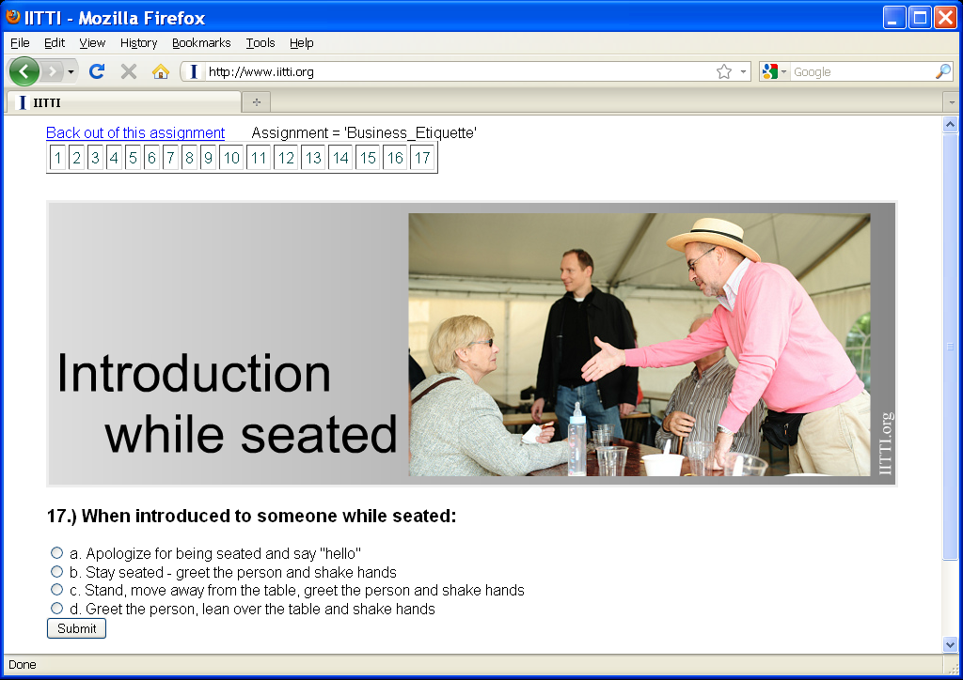

Chapter 3 Content of the test

Here is a guide to what is covered in the Level 1 "Corporate Basic" exam.

Professional Appearance
Business Dress – the differences between formal, semi-formal, and informal
Use of Colour – different colours that make you more authoritative, caring,
approachable or energetic
Fabrics, Prints, Patterns – the use of wool, cotton, or synthetic materials,
prints such as floral, plaids, and matte vs. shiny
Grooming, Hygiene – hair styles, body scents, tattoos

Business Etiquette
Definitions – what is the definition of the words "etiquette", "manners"
Networking – purpose of networking, what to talk about, behaviours to avoid
Introduction – introducing lower rank to higher rank, introducing one's self
Handshakes – positioning and motion of handshake
Name tags – correct placement of a name tag
Business Cards – how to give and receive a business card
Behavior – appropriate and inappropriate behavior in a work environment
Meetings – who leads a meeting, what about cellphones?
Job Interview – who leads an interview? how to follow up?
Body Language – the personal space
Eye Contact – how long is an eye contact for business?
Telephone & Techno-Etiquette – how to put customers on hold? how to answer calls?
Email Etiquette – salutation usage, using capital letters
Social Media Etiquette – abbreviations, what not to post
Good Manners: Everyday Applications – how to use a wet towel in a restaurant,
where can a lady apply make-up?

Dining Etiquette
Business Dining Etiquette – who is the most important?
Business Seating Arrangement – is it male-female-male or is it gender-neutral?
Duties of Host & Guests – specific protocols for hosts and guests at home and
at a restaurant
Categories of Meals – a four-course meal consists of what?
Place Settings – placement of forks and knives, plates, glasses
Wine & Beverages – basic knowledge of wine and wine pairing
Utensils – recognize different types of knives, forks, spoons
Table Manners – what to do with your elbows, how to pass food around table
European vs. American Dining Style – what are they?
Difficult Foods – appropriate way to eat them
Tipping – how much?

Chapter 4 How can we adopt IITTI?

What is the first step?
The first thing to do is to contact us to get the latest copy of the IITTI Standards and Guidelines (S&Gs) document. This document specifies all the standardized international corporate etiquette and image procedures, and will give you a general idea of what is covered in each exam level.

The best way to contact us is to send us an email, or get in touch with a qualified image consultant who uses the IITTI standard.

How can we advertise IITTI in our recruitment?
You may want to surf onto our website. We have set up a specific area for employers. Go into this area and you will find an item called

"How to tell people we welcome IITTI?"

How can we verify that a job-seeker really had passed an IITTI test?
On our website under employers' area, you can directly type in an IITTI certificate holder's ID to independently verify his/her standing. (The user's ID should have been given to you on the job candidate's résumé. They have been instructed to include their user ID with their job applications.)

Contact IITTI at:

Institute of Image Training and Testing International
Vancouver, Canada
Tel: (604) 231-8197
web: www.IITTI.org
email: info@IITTI.org

2011-2016 Institute of Image Training and Testing International (IITTI).
You can freely distribute this document.

